**INDIA GENERAL ELECTIONS ANALYSIS 2024**

**Total Seats:**

SELECT DISTINCT

COUNT(Parliament_Constituency) AS 'Total Seats'

FROM

constituencywise_results;

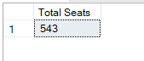

**What is the total number of seats available for elections in each state?**

SELECT

states.State,

COUNT(Parliament_Constituency) AS 'Total Seats Available'

FROM

states

JOIN

statewise_results

ON states.State_ID = statewise_results.State_ID

GROUP BY

states.State;

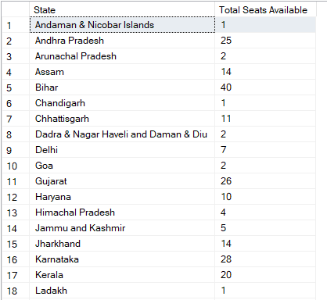 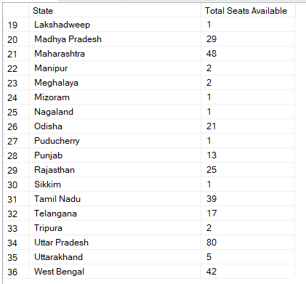

**Total Seats Won by NDA Alliance:**

SELECT

SUM(Won) AS 'NDA Total Seats'

FROM

partywise_results

WHERE

Party IN (

'Bharatiya Janata Party - BJP',

'Telugu Desam - TDP',

'Janata Dal (United) - JD(U)',

'Shiv Sena - SHS',

'AJSU Party - AJSUP',

'Apna Dal (Soneylal) - ADAL',

'Asom Gana Parishad - AGP',

'Hindustani Awam Morcha (Secular) - HAMS',

'Janasena Party - JnP',

'Janata Dal (Secular) - JD(S)',

'Lok Janshakti Party(Ram Vilas) - LJPRV',

'Nationalist Congress Party - NCP',

'Rashtriya Lok Dal - RLD',

'Sikkim Krantikari Morcha - SKM'

);

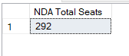

**Seats Won by NDA Alliance Parties:**

SELECT

Party as 'NDA Alliance Party', Won as 'Seats won'

FROM

partywise_results

WHERE

Party IN (

'Bharatiya Janata Party - BJP',

'Telugu Desam - TDP',

'Janata Dal (United) - JD(U)',

'Shiv Sena - SHS',

'AJSU Party - AJSUP',

'Apna Dal (Soneylal) - ADAL',

'Asom Gana Parishad - AGP',

'Hindustani Awam Morcha (Secular) - HAMS',

'Janasena Party - JnP',

'Janata Dal (Secular) - JD(S)',

'Lok Janshakti Party(Ram Vilas) - LJPRV',

'Nationalist Congress Party - NCP',

'Rashtriya Lok Dal - RLD',

'Sikkim Krantikari Morcha - SKM'

)

ORDER BY

Won DESC;

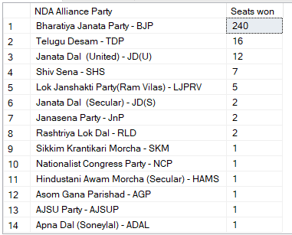

**Total Seats Won by I.N.D.I.A. Alliance:**

SELECT

SUM(Won) as 'INDIA Total Seats'

FROM

partywise_results

WHERE

Party IN (

'Indian National Congress - INC',

'Aam Aadmi Party - AAAP',

'All India Trinamool Congress - AITC',

'Bharat Adivasi Party - BHRTADVSIP',

'Communist Party of India (Marxist) - CPI(M)',

'Communist Party of India (Marxist-Leninist) (Liberation) - CPI(ML)(L)',

'Communist Party of India - CPI',

'Dravida Munnetra Kazhagam - DMK',

'Indian Union Muslim League - IUML',

'Nat`Jammu & Kashmir National Conference - JKN',

'Jharkhand Mukti Morcha - JMM',

'Jammu & Kashmir National Conference - JKN',

'Kerala Congress - KEC',

'Marumalarchi Dravida Munnetra Kazhagam - MDMK',

'Nationalist Congress Party Sharadchandra Pawar - NCPSP',

'Rashtriya Janata Dal - RJD',

'Rashtriya Loktantrik Party - RLTP',

'Revolutionary Socialist Party - RSP',

'Samajwadi Party - SP',

'Shiv Sena (Uddhav Balasaheb Thackrey) - SHSUBT',

'Viduthalai Chiruthaigal Katchi - VCK'

);

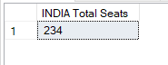

**Seats Won by I.N.D.I.A. Alliance Parties:**

SELECT

Party as 'INDIA Alliance Party', Won as 'Seats won'

FROM

partywise_results

WHERE

Party IN (

'Indian National Congress - INC',

'Aam Aadmi Party - AAAP',

'All India Trinamool Congress - AITC',

'Bharat Adivasi Party - BHRTADVSIP',

'Communist Party of India (Marxist) - CPI(M)',

'Communist Party of India (Marxist-Leninist) (Liberation) - CPI(ML)(L)',

'Communist Party of India - CPI',

'Dravida Munnetra Kazhagam - DMK',

'Indian Union Muslim League - IUML',

'Nat`Jammu & Kashmir National Conference - JKN',

'Jharkhand Mukti Morcha - JMM',

'Jammu & Kashmir National Conference - JKN',

'Kerala Congress - KEC',

'Marumalarchi Dravida Munnetra Kazhagam - MDMK',

'Nationalist Congress Party Sharadchandra Pawar - NCPSP',

'Rashtriya Janata Dal - RJD',

'Rashtriya Loktantrik Party - RLTP',

'Revolutionary Socialist Party - RSP',

'Samajwadi Party - SP',

'Shiv Sena (Uddhav Balasaheb Thackrey) - SHSUBT',

'Viduthalai Chiruthaigal Katchi - VCK'

)

ORDER BY

Won DESC;

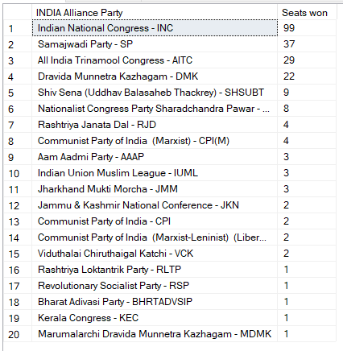

**Add new column field in table Alliance to get the Party Allianz as NDA, I.N.D.I.A and OTHER:**

ALTER TABLE partywise_results

ADD

Alliance varchar(50);

-- INDIA

UPDATE

partywise_results

SET

Alliance = 'I.N.D.I.A'

WHERE

party IN (

'Indian National Congress - INC',

'Aam Aadmi Party - AAAP',

'All India Trinamool Congress - AITC',

'Bharat Adivasi Party - BHRTADVSIP',

'Communist Party of India (Marxist) - CPI(M)',

'Communist Party of India (Marxist-Leninist) (Liberation) - CPI(ML)(L)',

'Communist Party of India - CPI',

'Dravida Munnetra Kazhagam - DMK',

'Indian Union Muslim League - IUML',

'Jammu & Kashmir National Conference - JKN',

'Jharkhand Mukti Morcha - JMM',

'Kerala Congress - KEC',

'Marumalarchi Dravida Munnetra Kazhagam - MDMK',

'Nationalist Congress Party Sharadchandra Pawar - NCPSP',

'Rashtriya Janata Dal - RJD',

'Rashtriya Loktantrik Party - RLTP',

'Revolutionary Socialist Party - RSP',

'Samajwadi Party - SP',

'Shiv Sena (Uddhav Balasaheb Thackrey) - SHSUBT',

'Viduthalai Chiruthaigal Katchi - VCK'

);

-- NDA

UPDATE

partywise_results

SET

Alliance = 'NDA'

WHERE

party IN (

'Bharatiya Janata Party - BJP',

'Telugu Desam - TDP',

'Janata Dal (United) - JD(U)',

'Shiv Sena - SHS',

'AJSU Party - AJSUP',

'Apna Dal (Soneylal) - ADAL',

'Asom Gana Parishad - AGP',

'Hindustani Awam Morcha (Secular) - HAMS',

'Janasena Party - JnP',

'Janata Dal (Secular) - JD(S)',

'Lok Janshakti Party(Ram Vilas) - LJPRV',

'Nationalist Congress Party - NCP',

'Rashtriya Lok Dal - RLD',

'Sikkim Krantikari Morcha - SKM'

);

-- OTHER

UPDATE

partywise_results

SET

Alliance = 'OTHER'

WHERE

Alliance IS NULL;

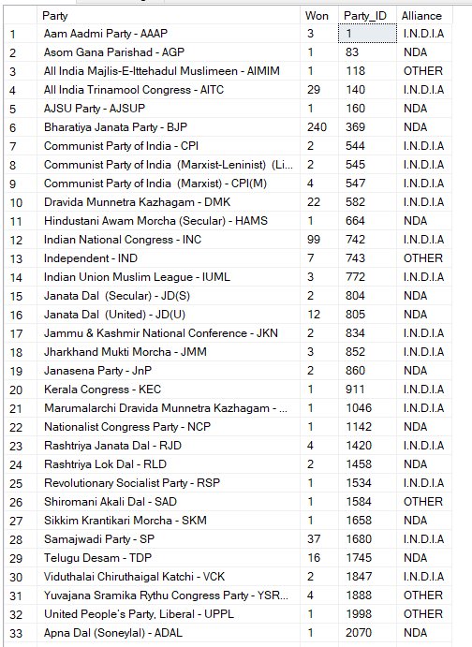

**Which party alliance (NDA, I.N.D.I.A, or OTHER) won the most seats across all states?**

SELECT

Alliance,

SUM(Won) as 'Total Seats Won'

FROM

partywise_results

GROUP BY

Alliance

ORDER BY

'Total Seats Won' DESC;

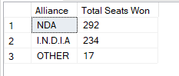

**Winning candidate's name, their party name, total votes, and the margin of victory for a specific state and constituency?**

SELECT

Winning_Candidate AS 'Candidate Name',

Party AS 'Party Name',

Total_Votes AS 'Total Votes',

cr.Margin as 'Margin of Victory',

Alliance,

Constituency_Name AS 'Constituency',

states.State AS 'State'

FROM

constituencywise_results cr

JOIN

statewise_results sr ON cr.Parliament_Constituency= sr.Parliament_Constituency

JOIN

states ON sr.State_ID = states.State_ID

JOIN

partywise_results pr ON pr.Party_ID = cr.Party_ID

WHERE

Constituency_Name = 'MAINPURI';



**What is the distribution of EVM votes versus postal votes for candidates in a specific constituency?**

SELECT

cr.Constituency_Name,

cd.Candidate,

cd.EVM_Votes,

cd.Postal_Votes,

cd.Total_Votes

FROM

constituencywise_details cd

JOIN

constituencywise_results cr ON cd.Constituency_ID = cr.Constituency_ID

WHERE

Constituency_Name = 'JAIPUR';

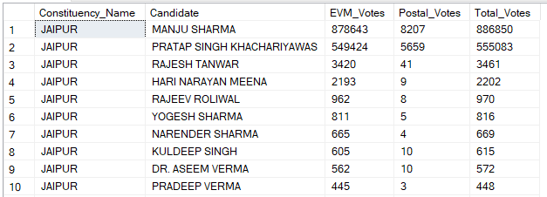

**Which parties won the most seats in a specific State, and how many seats did each party win?**

SELECT

pr.Party,

count (Constituency_ID) as 'Total Seats'

FROM

constituencywise_results cr

JOIN

statewise_results sr ON cr.Parliament_Constituency = sr.Parliament_Constituency

JOIN

states s ON sr.State_ID = s.State_ID

JOIN

partywise_results pr ON pr.Party_ID = cr.Party_ID

WHERE

s.State ='Rajasthan'

GROUP BY

pr.Party

ORDER BY

'Total Seats' DESC;

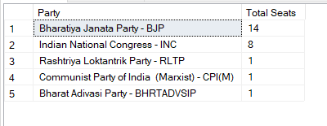

**What is the total number of seats won by each party alliance (NDA, I.N.D.I.A, and OTHER) in each state for the India Elections 2024?**

SELECT

s.State,

SUM(CASE WHEN Alliance = 'NDA' THEN 1

ELSE 0

END) AS 'NDA Seats Won',

SUM(CASE WHEN Alliance = 'I.N.D.I.A' THEN 1

ELSE 0

END) AS 'INDIA Seats Won',

SUM(CASE WHEN Alliance = 'OTHER' THEN 1

ELSE 0

END) AS 'OTHER Seats Won'

FROM

constituencywise_results cr

JOIN

statewise_results sr ON cr.Parliament_Constituency = sr.Parliament_Constituency

JOIN

states s ON sr.State_ID = s.State_ID

JOIN

partywise_results pr ON pr.Party_ID = cr.Party_ID

GROUP BY

s.State

ORDER BY

s.State;

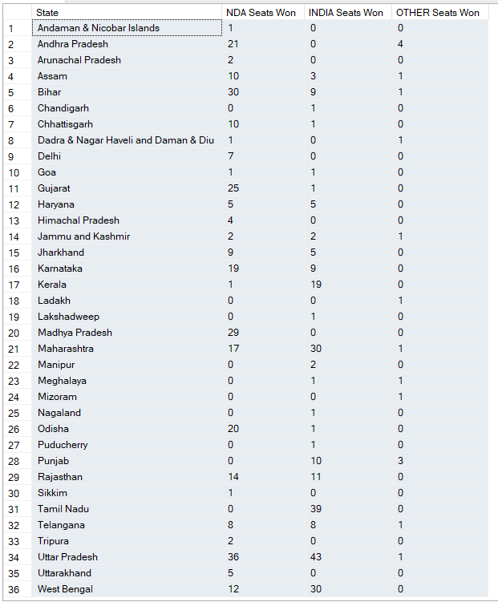

**Which candidate received the highest number of EVM votes in each constituency (Top 10)?**

SELECT

TOP 10

cd.Candidate,

cd.Party,

cd.EVM_Votes,

cr.Constituency_Name

FROM

constituencywise_details cd

JOIN

constituencywise_results cr on cd.Constituency_ID = cr.Constituency_ID

WHERE

cd.EVM_Votes = (SELECT MAX(cd1.EVM_Votes)

FROM constituencywise_details cd1

WHERE cd1.Constituency_ID = cd.Constituency_ID

)

ORDER BY

cd.EVM_Votes desc;

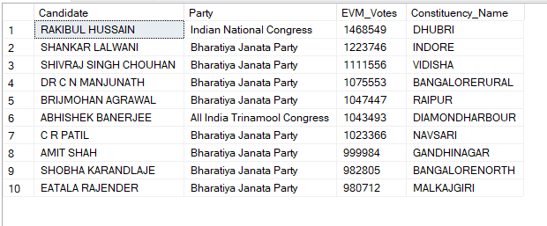

**Which candidate won and which candidate was the runner-up in each constituency for the 2024 elections?**

WITH

RankofCandidate AS (

SELECT

Constituency_ID,

Candidate,

Party,

EVM_Votes,

Postal_Votes,

Total_Votes,

RANK() OVER(PARTITION BY Constituency_ID ORDER BY Total_Votes DESC) AS 'Vote rank'

FROM

constituencywise_details

)

SELECT

cr.Constituency_ID AS 'Constituency ID',

cr.Constituency_Name AS 'Constituency Name',

MAX(CASE WHEN roc.[Vote rank] = 1 THEN roc.Candidate END) AS Winner,

MAX(CASE WHEN roc.[Vote rank] = 2 THEN roc.Candidate END) AS Runnerup

FROM

RankofCandidate roc

JOIN

constituencywise_results cr ON roc.Constituency_ID = cr.Constituency_ID

GROUP BY

cr.Constituency_ID, cr.Constituency_Name;

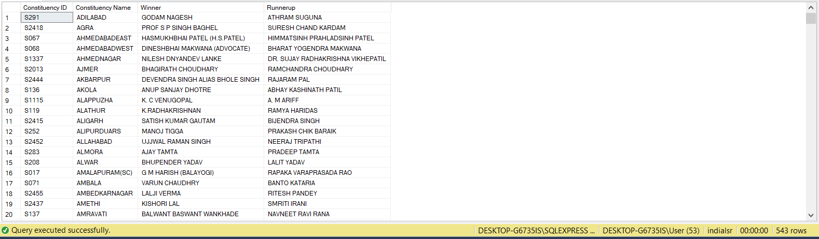

**Which candidate won and which candidate was the runner-up in each constituency of State for the 2024 elections?**

WITH

RankofCandidate AS (

SELECT cd.Constituency_ID,

Candidate,

Party,

EVM_Votes,

Postal_Votes,

cd.Total_Votes,

RANK() OVER(PARTITION BY cd.Constituency_ID ORDER BY cd.Total_Votes DESC) as 'Vote rank'

FROM

constituencywise_details cd

JOIN

constituencywise_results cr ON cd.Constituency_ID = cr.Constituency_ID

JOIN

statewise_results sr ON cr.Parliament_Constituency = sr.Parliament_Constituency

JOIN

states s on sr.State_ID = s.State_ID

WHERE

s.State = 'Rajasthan')

SELECT

cr.Constituency_ID AS 'Constituency ID',

cr.Constituency_Name AS 'Constituency Name',

MAX(CASE WHEN roc.[Vote rank] = 1 THEN roc.Candidate END) AS Winner,

MAX(CASE WHEN roc.[Vote rank] = 2 THEN roc.Candidate END) AS Runnerup

FROM

RankofCandidate roc

JOIN

constituencywise_results cr on roc.Constituency_ID = cr.Constituency_ID

GROUP BY cr.Constituency_ID, cr.Constituency_Name;

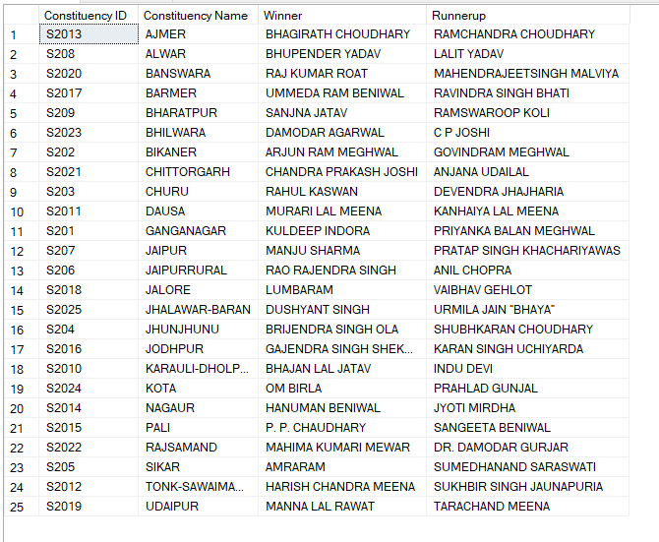

**Top 10 Candidates won by largest margins:**

SELECT

TOP 10

Parliament_Constituency as Constituency,

Winning_Candidate, Total_Votes AS 'Total Votes',

FORMAT(Margin, '###,###,###') AS 'Win Margin',

Party,

Alliance

FROM

constituencywise_results cr

JOIN

partywise_results pr ON cr.Party_ID = pr.Party_ID

ORDER BY

Margin DESC;

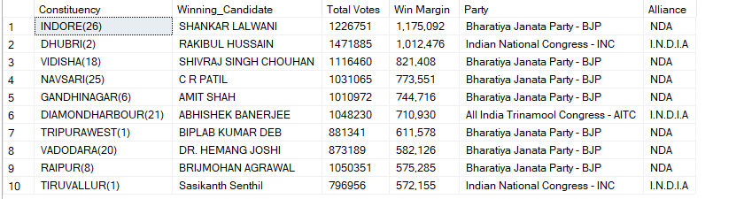

**Top 10 parties by total number of votes:**

SELECT

Top 10

Party,

FORMAT(SUM(Total_Votes),

'###,###,###') as 'Total Votes'

FROM

constituencywise_details

GROUP BY

Party

ORDER BY

SUM(Total_Votes) DESC;

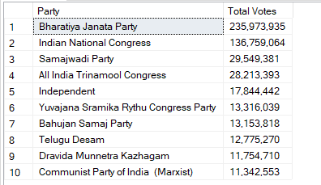

**Total votes by ALLIANCE:**

SELECT

Alliance,

FORMAT(SUM(cd.Total_Votes), '###,###,###') as 'Total Votes'

FROM

constituencywise_details cd

JOIN

constituencywise_results cr on cd.Constituency_ID = cr.Constituency_ID

JOIN

partywise_results pr on cr.Party_ID = pr.Party_ID

GROUP BY

Alliance

ORDER BY

SUM(cd.Total_Votes) DESC;

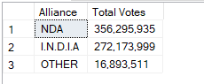

**Total number of Trailing Candidates by Party:**

SELECT

cd.Party,

COUNT(sr.Trailing_Candidate) AS 'Total Trailing Candidates'

FROM

constituencywise_results cr

JOIN

constituencywise_details cd ON cr.Constituency_ID = cd.Constituency_ID

JOIN

statewise_results sr ON cr.Parliament_Constituency = sr.Parliament_Constituency

WHERE

sr.Trailing_Candidate = cd.Candidate

GROUP BY

cd.Party

ORDER BY [

Total Trailing Candidates] DESC;

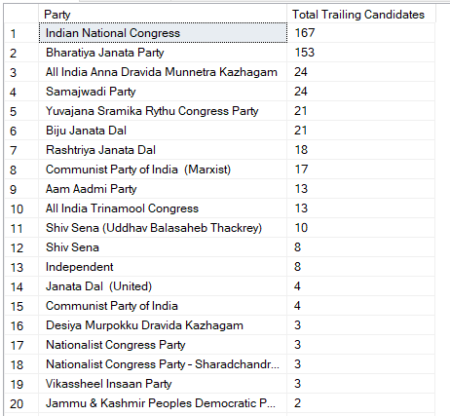

**Total number of Trailing Candidates by Alliance:**

SELECT

pr.Alliance,

COUNT(sr.Trailing_Candidate) AS TotalTrailingCandidates

FROM

constituencywise_results cr

JOIN

constituencywise_details cd ON cr.Constituency_ID = cd.Constituency_ID

JOIN

statewise_results sr ON cr.Parliament_Constituency = sr.Parliament_Constituency

JOIN

partywise_results pr ON cr.Party_ID = pr.Party_ID

WHERE

sr.Trailing_Candidate = cd.Candidate

GROUP BY

pr.Alliance

ORDER BY

TotalTrailingCandidates DESC;

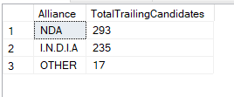

**Total vote share percentage of a Party:**

SELECT Party,

SUM(Total_Votes) AS 'Party Total Votes',

SUM(SUM(Total_Votes)) OVER() AS 'Total Votes',

CAST(SUM(Total_Votes) * 100.0 /(SUM(SUM(Total_Votes)) OVER()) AS DECIMAL(10,2)) AS 'Vote Share Percentage'

FROM

constituencywise_details

GROUP BY

Party

ORDER BY

SUM(Total_Votes) DESC;

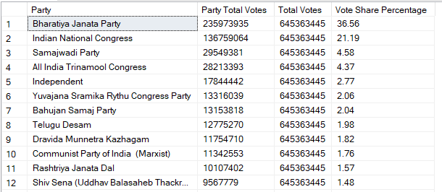

**Method -2**

WITH Party_Votes AS (

SELECT

Party,

SUM(Total_Votes) AS Total_Party_Votes

FROM constituencywise_details

GROUP BY Party

),

All_Votes1 AS (

SELECT SUM(Total_Votes) AS All_Votes FROM constituencywise_details

)

SELECT

p.Party,

p.Total_Party_Votes,

t.All_Votes,

CAST(p.Total_Party_Votes * 100.0 / t.All_Votes AS DECIMAL(10,2)) AS Vote_Share_Percentage

FROM

Party_Votes p

CROSS JOIN

All_Votes1 t

ORDER BY

Vote_Share_Percentage DESC;

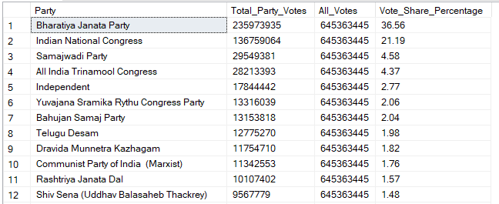

**Total vote share percentage of a Party in a specific state:**

WITH PartyStateVotes AS (

SELECT

cd.Party,

s.State,

SUM(cd.Total_Votes) AS TotalPartyVotes

FROM

constituencywise_details cd

JOIN

constituencywise_results cr ON cd.Constituency_ID = cr.Constituency_ID

JOIN

statewise_results sr ON cr.Parliament_Constituency = sr.Parliament_Constituency

JOIN

states s ON sr.State_ID = s.State_ID

GROUP BY

cd.Party, s.State

),

TotalStateVotes AS (

SELECT

s.State,

SUM(cd.Total_Votes) AS TotalVotesInState

FROM

constituencywise_details cd

JOIN

constituencywise_results cr ON cd.Constituency_ID = cr.Constituency_ID

JOIN

statewise_results sr ON cr.Parliament_Constituency = sr.Parliament_Constituency

JOIN

states s ON sr.State_ID = s.State_ID

GROUP BY

s.State

)

SELECT

p.State,

p.Party,

p.TotalPartyVotes,

t.TotalVotesInState,

CAST(p.TotalPartyVotes * 100.0 / t.TotalVotesInState AS DECIMAL(10,2)) AS VoteSharePercentage

FROM

PartyStateVotes p

INNER JOIN

TotalStateVotes t ON p.State = t.State

WHERE

p.State = 'Rajasthan'

ORDER BY

p.State, VoteSharePercentage DESC;

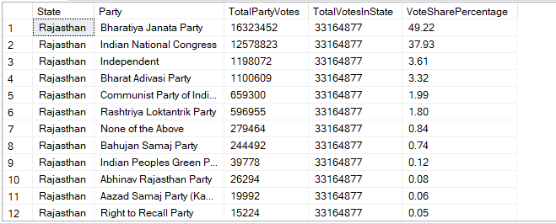

**Total vote share percentage of a Alliance:**

WITH Party_Votes AS (

SELECT

pr.Alliance,

SUM(cd.Total_Votes) AS Total_Alliance_Votes

FROM constituencywise_details cd

JOIN constituencywise_results cr ON cd.Constituency_ID = cr.Constituency_ID

JOIN partywise_results pr ON cr.Party_ID = pr.Party_ID

GROUP BY Alliance

),

All_Votes1 AS (

SELECT SUM(Total_Votes) AS All_Votes FROM constituencywise_details

)

SELECT

p.Alliance,

p.Total_Alliance_Votes,

t.All_Votes,

CAST(p.Total_Alliance_Votes * 100.0 / t.All_Votes AS DECIMAL(10,2)) AS Vote_Share_Percentage

FROM

Party_Votes p

CROSS JOIN

All_Votes1 t

ORDER BY

Vote_Share_Percentage DESC;

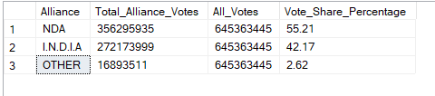

**Total vote share percentage of an Alliance in a specific state:**

WITH AllianceStateVotes AS (

SELECT

pr.Alliance,

s.State,

SUM(cd.Total_Votes) AS TotalAllianceVotes

FROM constituencywise_details cd

JOIN constituencywise_results cr ON cd.Constituency_ID = cr.Constituency_ID

JOIN partywise_results pr ON cr.Party_ID = pr.Party_ID

JOIN statewise_results sr ON cr.Parliament_Constituency = sr.Parliament_Constituency

JOIN states s ON sr.State_ID = s.State_ID

GROUP BY pr.Alliance, s.State

),

TotalStateVotes AS (

SELECT

s.State,

SUM(cd.Total_Votes) AS TotalVotesInState

FROM constituencywise_details cd

JOIN constituencywise_results cr ON cd.Constituency_ID = cr.Constituency_ID

JOIN statewise_results sr ON cr.Parliament_Constituency = sr.Parliament_Constituency

JOIN states s ON sr.State_ID = s.State_ID

GROUP BY s.State

)

SELECT

p.State,

p.Alliance,

p.TotalAllianceVotes,

t.TotalVotesInState,

CAST(p.TotalAllianceVotes * 100.0 / t.TotalVotesInState AS DECIMAL(10,2)) AS VoteSharePercentage

FROM AllianceStateVotes p

INNER JOIN TotalStateVotes t ON p.State = t.State

WHERE p.State = 'Rajasthan'

ORDER BY p.State, VoteSharePercentage DESC;

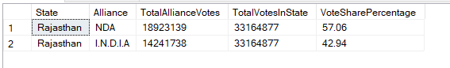

**Top 10 Closest Contests (Lowest victory margin):**

SELECT TOP 10

cr.Constituency_Name,

cr.Winning_Candidate,

cr.Party_ID,

cr.Margin,

s.State

FROM constituencywise_results cr

JOIN statewise_results sr ON cr.Parliament_Constituency = sr.Parliament_Constituency

JOIN states s ON sr.State_ID = s.State_ID

WHERE cr.Margin != 0

ORDER BY cr.Margin ASC;

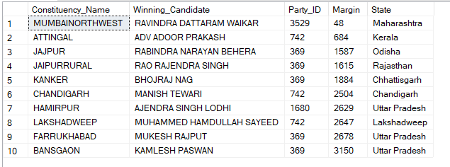

**Top 10 Party-wise Average Margin of Victory (Parties with 7 or more seats):**

SELECT

TOP 10

p.Party, p.Won,

AVG(c.Margin) AS Avg_Margin

FROM

constituencywise_results c

JOIN

partywise_results p ON c.Party_ID = p.Party_ID

WHERE p.Won > 6

GROUP BY

p.Party, p.Won

ORDER BY

Avg_Margin DESC;

**TOP 10 Constituency-wise NOTA Votes Analysis:**

SELECT TOP 10

cr.Constituency_Name,

cd.Total_Votes AS NOTA_Votes,

CAST(cd.of_Votes AS DECIMAL(10,2)) AS NOTA_Percentage

FROM

constituencywise_details cd

JOIN

constituencywise_results cr ON cd.Constituency_ID = cr.Constituency_ID

WHERE

cd.Candidate = 'NOTA'

ORDER BY

NOTA_Percentage DESC;

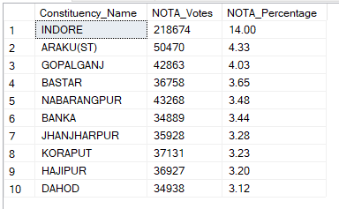

**Identify swing constituencies (where the margin of victory is less than 5%) and analyze party performance in these constituencies:**

SELECT

cr.Constituency_Name,

cr.Winning_Candidate,

cr.Margin,

pr.Party,

ROW_NUMBER() OVER(PARTITION BY pr.Party ORDER BY cr.Margin) AS Cumulative_Count_by_Party

FROM

constituencywise_results cr

JOIN

partywise_results pr ON cr.Party_ID = pr.Party_ID

WHERE

cr.Margin < (cr.Total_Votes * 0.05)

ORDER BY

cr.Margin ASC;

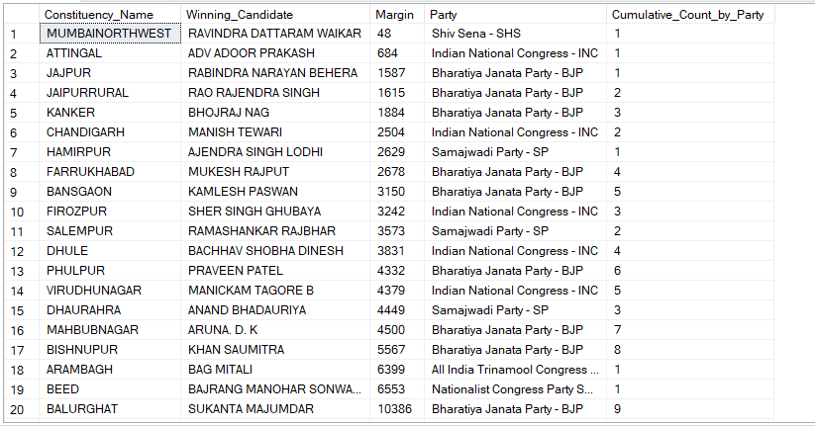

**Analyze party performance in these swing constituencies:**

SELECT

pr.Party,

COUNT(cr.Margin) AS Total_Seats

FROM

constituencywise_results cr

JOIN

partywise_results pr ON cr.Party_ID = pr.Party_ID

WHERE

cr.Margin < (cr.Total_Votes * 0.05)

GROUP BY

pr.Party

ORDER BY

Total_Seats desc;

